­

Brandon Hough

CPEN 3710

LQF316

Lab Exercise #11

**Console Output (unequal roots):**

a:1 b:5 c:2

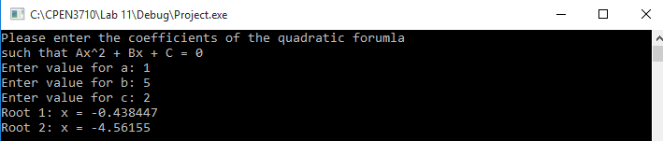

a:21.54 b:-87.5 c:18

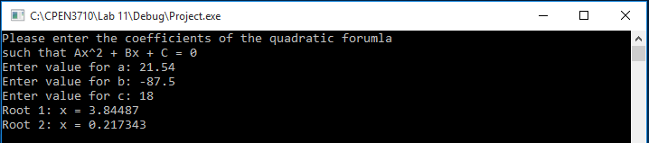

**Console Output (real, equal roots):**

a:1 b:-10 c:25

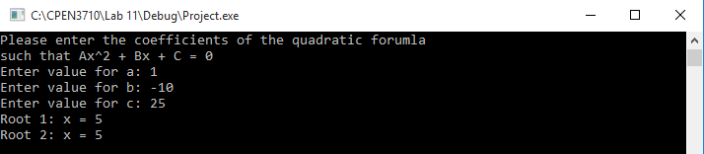

a:4 b:-12 c:9.0

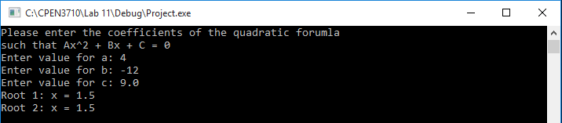

**Console Output (complex roots):**

a:3.75 b:-3.19 c:53

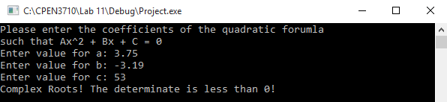

a:11.17 b:8 c:81.66

